Day 13 Social Media Notes

**Need to install Lombok for Eclipse following instructions here https://www.baeldung.com/lombok-ide**

**Show students working twitter app, show the database it uses in /console**

In command window type

C:\_app\Lombok>java -jar lombok-1.18.12.jar

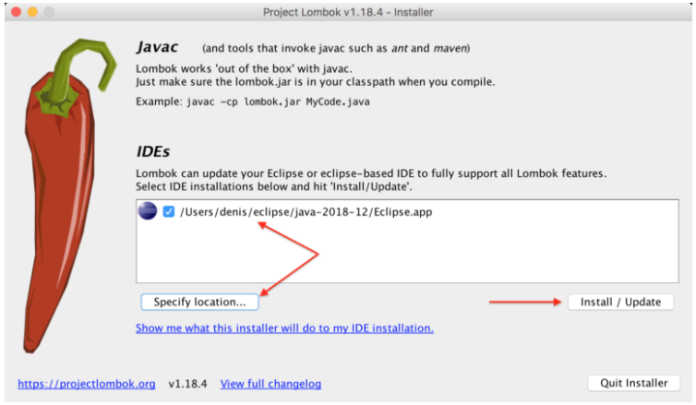

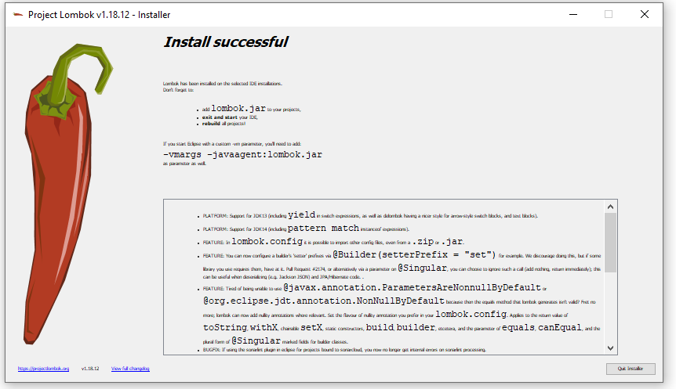

(slide 8) Create Spring Boot Starter project with following addons

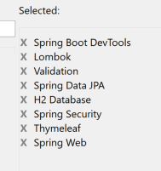

(Slide 9) Add this to POM.XML

<dependency>

<groupId>org.thymeleaf.extras</groupId>

<artifactId>thymeleaf-extras-springsecurity4</artifactId>

<version>3.0.2.RELEASE</version>

</dependency>

<dependency>

<groupId>org.ocpsoft.prettytime</groupId>

<artifactId>prettytime</artifactId>

<version>4.0.1.Final</version>

</dependency>

Step through the rest of the slides, reference existing Twitter app but be careful about copying.

After starting successfully try to access <http://localhost:8080/signup>

Signup a user than access console to see if they are there.

Access <http://localhost:8080/login>

Should be taken to <http://localhost:8080/tweets>

Go to <http://localhost:8080/tweets/new> and add a few tweets

Homework

1 In each of our html pages, we've included several css and js files. Break this out into a fragment and then include the fragment on each page.

Create head.html in templates/fragements, including <head> tags

Add the following to each html page

<head th:include="fragments/head">

<title id="title">Feed</title>

</head>

2 Add a sign up button to the login page so that it's easier to navigate. This will need to be a mini

form that just makes a get request

<form th:action="@{/?????}" method="get">

<button class="btn btn-md btn-primary btn-block" type="Submit">Sign up</button>

</form>

3 In our AuthorizationController, we sent back a success message in the model if the registration was successful. We haven't done anything with it yet. On the registration page, if a success message comes back, hide the form, display the success message, and display a button to navigate to the login page. If a user is filling out form still (no success message included in the model), then the page should look the same as it does now.

In registration.html

<div th:if=*"!${success}"*>

// wrap this div around whatever you want to hide after a successful registration

<div>

<div th:if="${success}">

<h2><span class="text-success" th:utext="${success}"></span></h2>

<br/>

<form th:action="@{/??????}" method="get">

<button class="btn btn-md btn-primary btn-block" type="Submit">Go to login page</button>

</form>

</div>

4. On the main feed page, display a message saying no tweets are available when that is the case, rather than showing an entirely blank page like we are right now.

<div th:if="${#lists.isEmpty(tweetList)}">

</div>

5 On the main feed page, improve the styling of the tweets. Check out the bootstrap list-group and list-group-item classes and use them to display each tweet inside of a box.